1. MS-Report-Payements-In From Month select jan-2020 and To month select feb-2020 and select valid tail(I was select 800HH tail) and click search button details are displayed in the table.

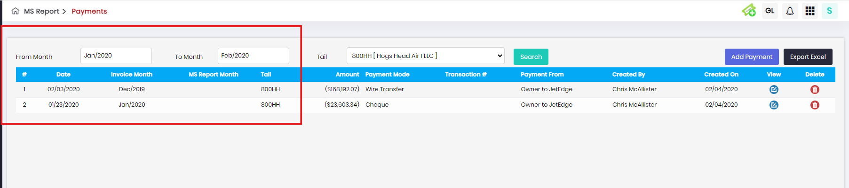

1. MS-Report-Expense Attach Invoice- When click edit button, details wont display.

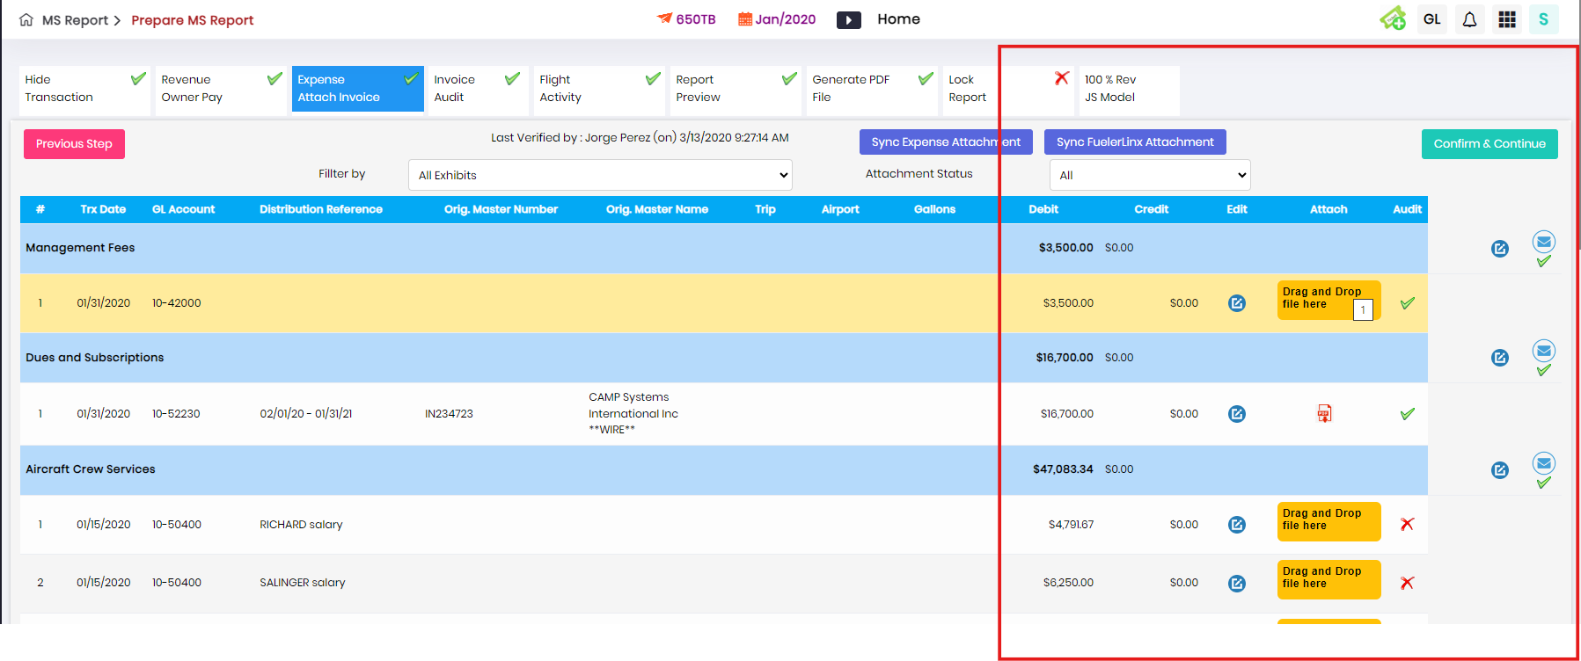

1. Reports-State Tax-In From Month select jan-2020 and To month select feb-2020 and select valid tail(I was select 800HH tail) and click search button details are displayed in the table.

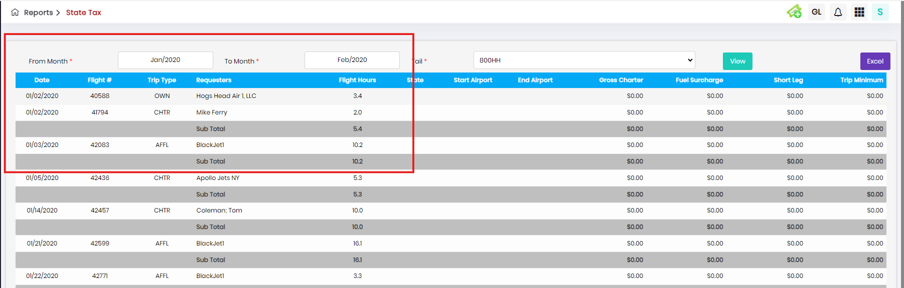

1. 4.Reports-Statement View-In From Month select jan-2020 and To month select feb-2020 and select valid tail(I was select 800HH tail) and click search button details are displayed in the table.

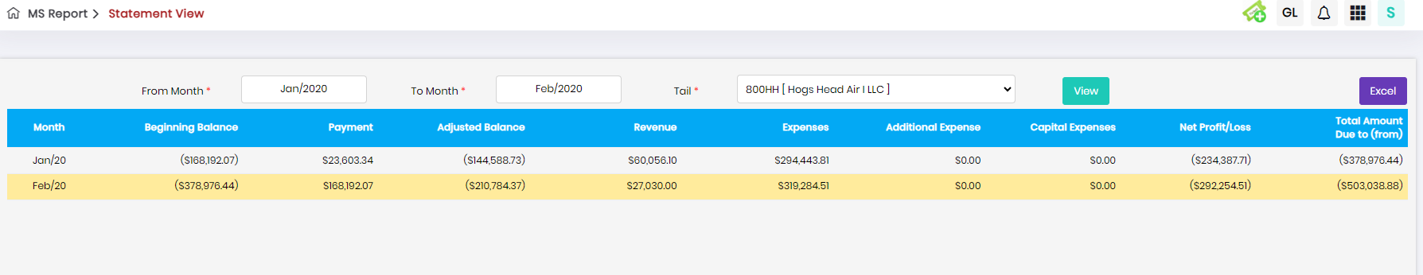

1. Reports-Statement view-Heading is displayed wrong details.

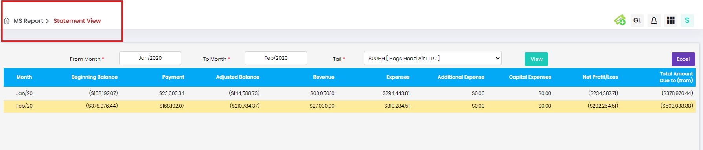

1. Reports-OP release details-In From Month select jan-2020 and To month select feb-2020 and click search button details are displayed in the table.

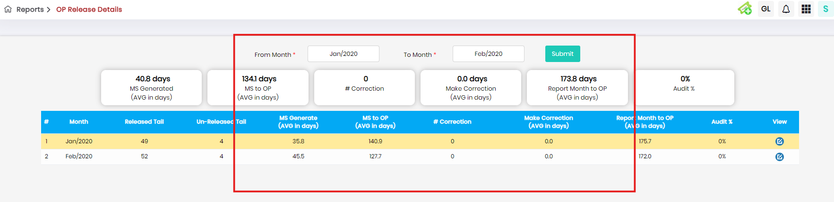

7.Edit Ledger-In from month Select jan-2020 and In to month select feb-2020 and select all tail and enter valid GL Code(40004) and click view button no alert pop up is displayed.